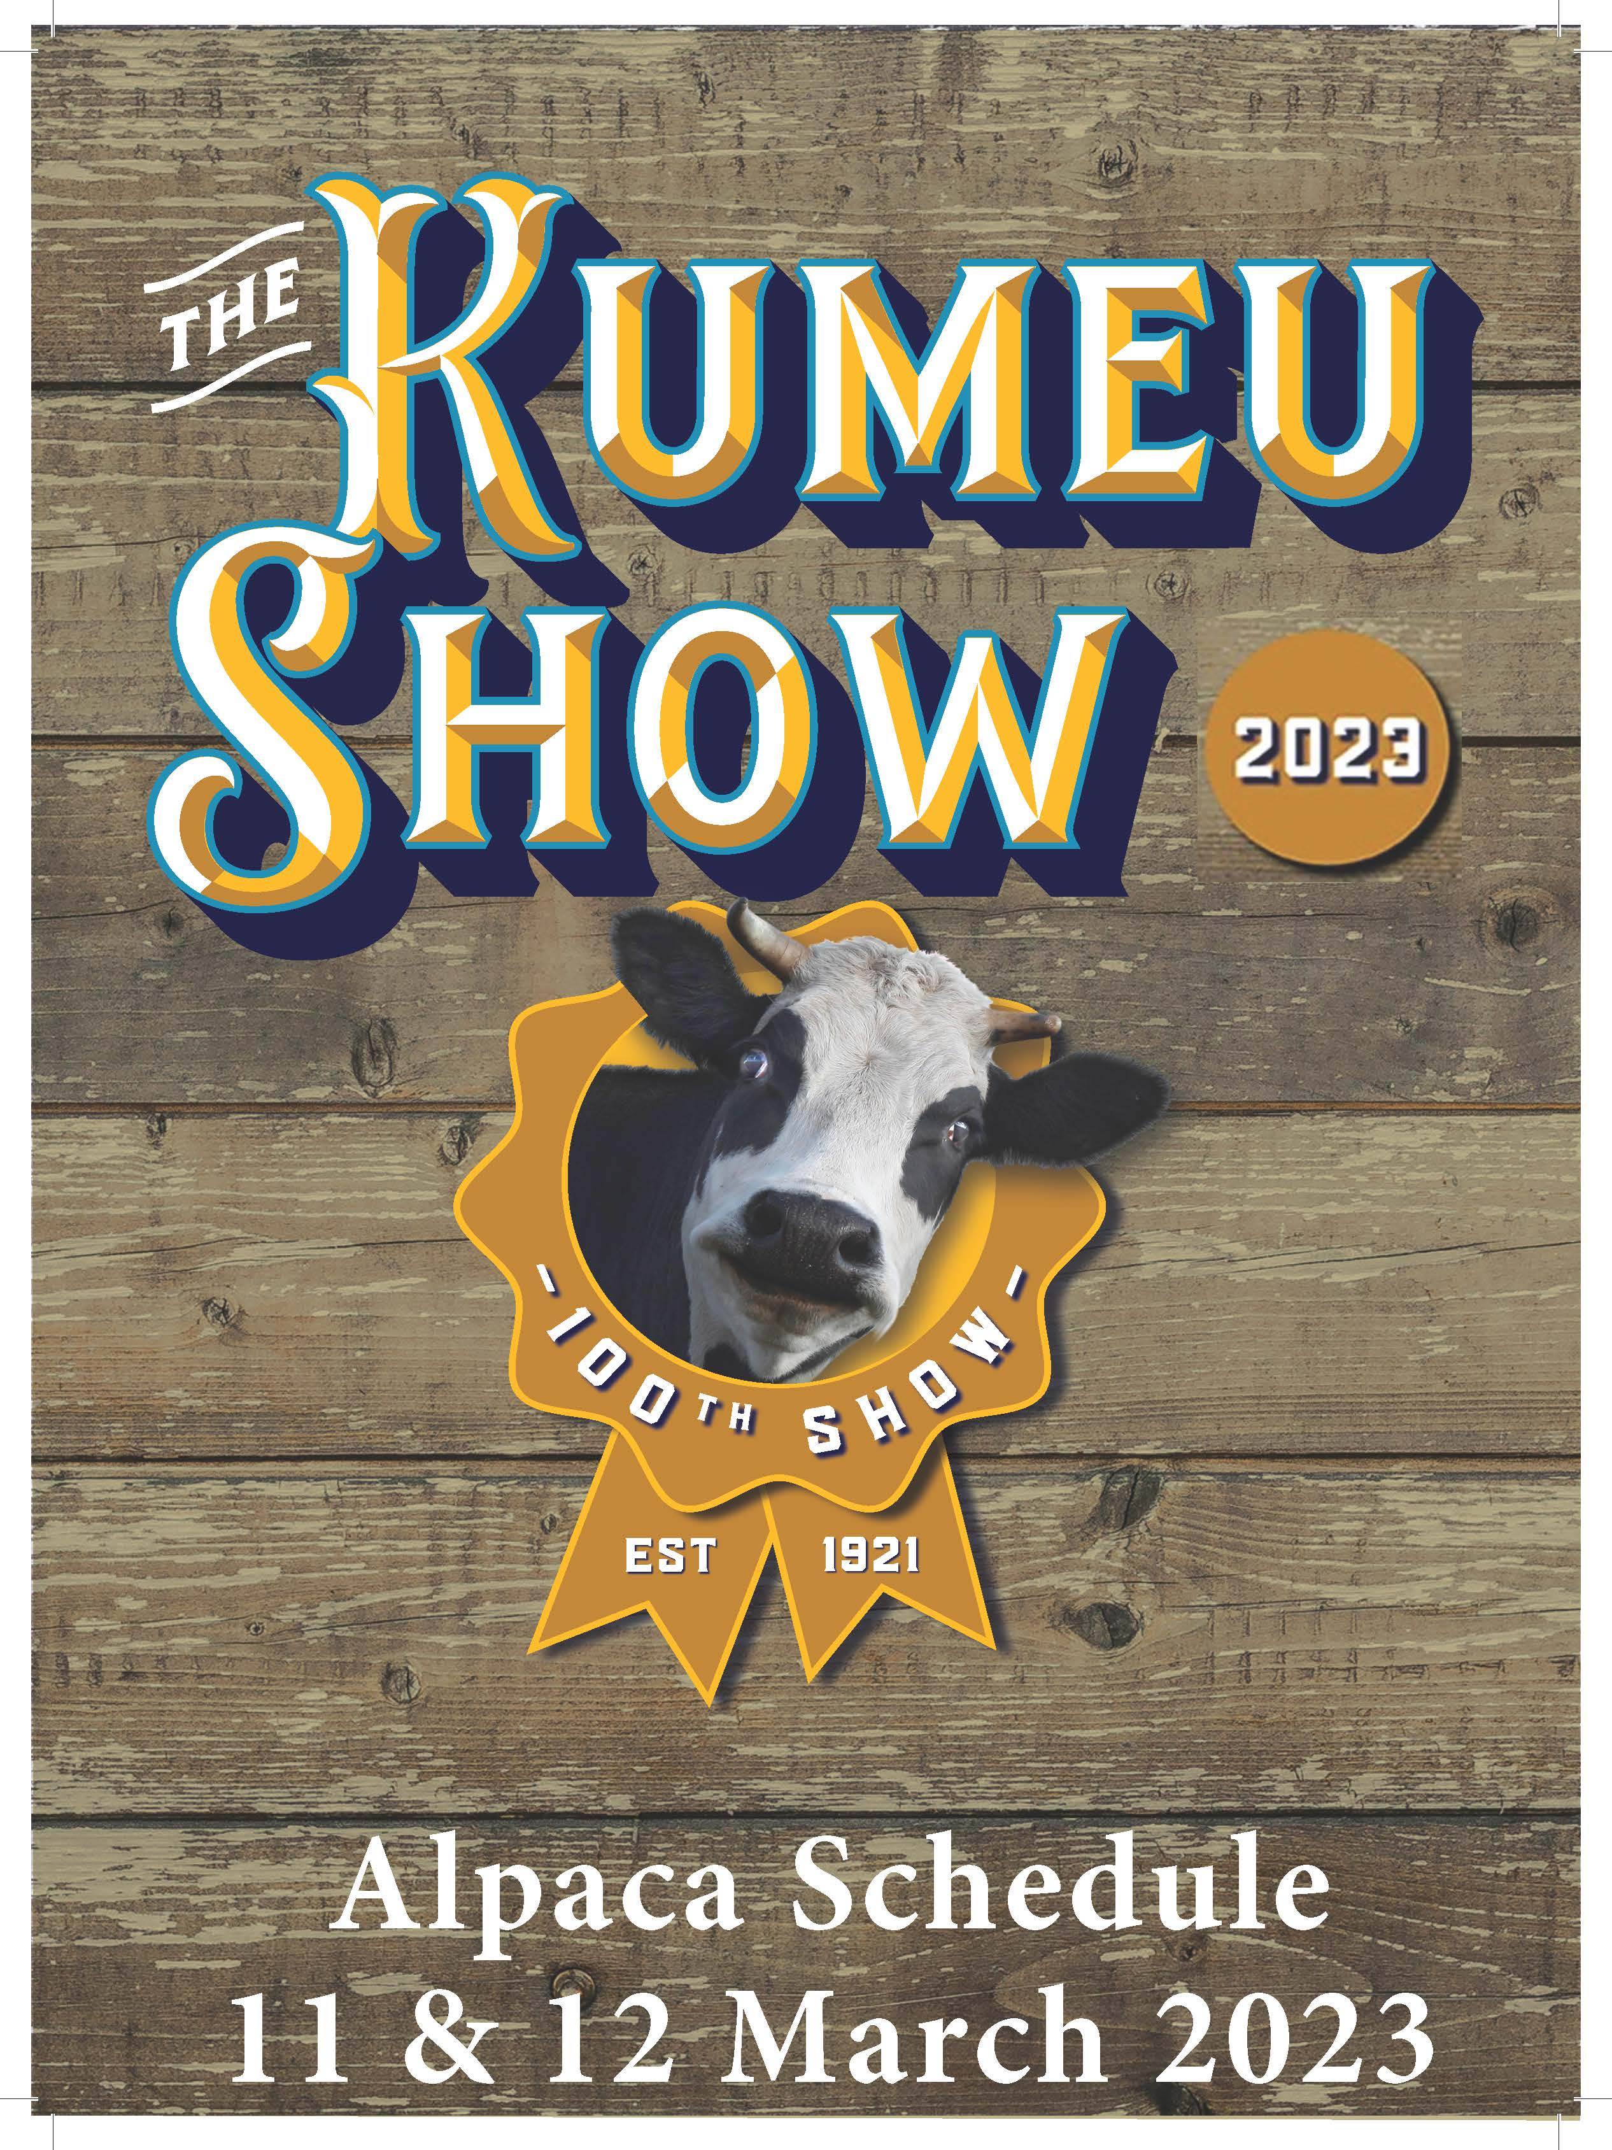

2023 KUMEU SHOW
Alpaca Show Saturday 11th March, 2023
General Promotion Day Sunday 12th March, 2023

Convenor: Ross Stevenson Phone: 09 4125000 Mobile: 021626551
& Toni Charteris email: kumeu2023@nuthouse.net.nz (Show Correspondence only)

Judges
Judge: Angela Preuss
Breed Judging, Suri and Huacaya: Saturday, 11th March 2023

All Alpacas to be penned by 8.30am – Judging to commence 9.00am

Entry Fees & Prizes: Entry fee $15 per animal. No charge for non-championship classes.
Prize Ribbons awarded.

Entries: Entries close Wednesday 1st March 2023.

Send hard copy entries to: Kumeu A & H Society, PO Box 2, Kumeu 0841
Email electronic entries to both the Show: info@kumeushow.co.nz
and Convenor using: kumeu23entry@nuthouse.net.nz

Entries processed only if:
- On Kumeu Show Entry Form
- Correct money Received
No entries taken on the day.
Incorrect entry forms will be posted back for correction and must be returned by the due date.
All care will be taken, however no responsibility is accepted for any errors or omissions on the day.

Conditions of Entry
- All animals must belong to a clear TB herd where whole herd testing is performed in accordance with the AANZ voluntary TB scheme. Copies of current TB Certificates to be enclosed with entry form.
- All Alpacas entered in Championship Classes must be registered with the IAR and carry a brass ear tag displaying its corresponding IAR number.
- The exhibitor is the owner(s) listed on the alpaca’s registration certificate.
In the case of a registered lease, the lessee is deemed the owner.
- The age of the alpaca is its age on the day of the show.
- All exhibitors or handlers must place their animals in the pens allotted by the Convenor.
Placements of animals in ‘trade pens’ will only be done with the permission of the Chief Steward.
- No animal shall be removed from the show prior to the completion of all classes without the express permission of the Chief Steward.
- Exhibitors requiring overnight pens for their alpacas MUST notify the convenor of their requirements at least a week prior to the show.

Each exhibitor must supervise and control their animals at all times and shall be liable for any hazards created, or accident / illness or damage caused, by the action of themselves or their animals at the show grounds.

Exhibitors must comply with the appropriate animal legislation and the Health and Safety at Work Act 2015.

No person is permitted in any judging ring without express permission of the head steward of that ring. Only persons directly responsible for an exhibit are permitted in the marshalling area.

No Dogs (other than Competition dogs and Dogs allowed by Legislation) are permitted on the Kumeu A&H Society Show grounds

Saturday 11th March 2023
Suri Breed Classes

White
8001 Junior Female Suri White (6 & under 12 months)
8002 Intermediate Female Suri White (12 & under 24 months)
8003 Senior Female Suri White (24 months & under 48 months)
8004 Mature Female Suri White (48 months +)

8005 Junior Male Suri White (6 & under 12 months)
8006 Intermediate Male Suri White (12 & under 24 months)
8007 Senior Male Suri White (24 months & under 48 months)
8008 Mature Male Suri White (48 months +)
Champion White Suri
Reserve Champion White Suri

Light Fawn
8011 Junior Female Suri Light Fawn (6 & under 12 months)
8012 Intermediate Female Suri Light Fawn (12 & under 24 months)
8013 Senior Female Suri Light Fawn (24 months & under 48 months)
8014 Mature Female Suri Light Fawn (48 months +)

8015 Junior Male Suri Light Fawn (6 & under 12 months)
8016 Intermediate Male Suri Light Fawn (12 & under 24 months)
8017 Senior Male Suri Light Fawn (24 months & under 48 months)
8018 Mature Male Suri Light Fawn (48 months +)

Champion Light Fawn Suri
Reserve Champion Light Fawn Suri

Mid/Dark Fawn
8021 Junior Female Suri Mid/Dark Fawn (6 & under 12 months)
8022 Intermediate Female Mid/Suri Dark Fawn (12 & under 24 months)
8023 Senior Female Suri Mid/Dark Fawn (24 months & under 48 months)
8024 Mature Female Suri Mid/Dark Fawn (48 months +)

8025 Junior Male Suri Dark Fawn (6 & under 12 months)
8026 Intermediate Male Suri Dark Fawn (12 & under 24 months)
8027 Senior Male Suri Dark Fawn (24 months & under 48 months)
8028 Mature Male Suri Dark Fawn (48 months +)
Champion Mid/Dark Fawn Suri
Reserve Champion Mid/Dark Fawn Suri

Brown
8031 Junior Female Suri Brown (6 & under 12 months)
8032 Intermediate Female Suri Brown (12 & under 24 months)
8033 Senior Female Suri Brown (24 months under 48 months)
8034 Mature Female Suri Brown (48 months +)

8035 Junior Male Suri Brown (6 & under 12 months)
8036 Intermediate Male Suri Brown (12 & under 24 months)
8037 Senior Male Suri Brown (24 months under 48 months)
8038 Mature Male Suri Brown (48 months +)
Champion Brown Suri
Reserve Champion Brown Suri

Roan
8041 Junior Female Suri Roan (6 & under 12 months)
8042 Intermediate Female Suri Roan (12 & under 24 months)
8043 Senior Female Suri Roan (24 under 48 months
8044 Mature Female Suri Roan (48 months +)

8045 Junior Male Suri Roan (6 & under 12 months)
8046 Intermediate Male Suri Roan (12 & under 24 months)
8047 Senior Male Suri Roan (24 under 48 months
8048 Mature Male Suri Roan (48 months +)

Champion Roan Suri
Reserve Champion Roan Suri

Grey
8051 Junior Female Suri Grey (6 & under 12 months)
8052 Intermediate Female Suri Grey (12 & under 24 months)
8053 Senior Female Suri Grey (24 under 48 months)
8054 Mature Female Suri Grey (48 months +)

8055 Junior Male Suri Grey (6 & under 12 months)
8056 Intermediate Male Suri Grey (12 & under 24 months)
8057 Senior Male Suri Grey (24 under 48 months)
8058 Mature Male Suri Grey (48 months +)

Champion Grey Suri
Reserve Champion Grey Suri

Fancy
8061 Junior Female Suri Fancy (6 & under 12 months)
8062 Intermediate Female Suri Fancy (12 & under 24 months)
8063 Senior Female Suri Fancy (24 under 48 months)
8064 Mature Female Suri Fancy (48 months +)

8065 Junior Male Suri Fancy (6 & under 12 months)
8066 Intermediate Male Suri Fancy (12 & under 24 months)
8067 Senior Male Suri Fancy (24 under 48 months)
8068 Mature Male Suri Fancy (48 months +)

Champion Fancy Suri
Reserve Champion Fancy Suri

Black
8071 Junior Female Suri Black (6 & under 12 months)
8072 Intermediate Female Suri Black (12 & under 24 months)
8073 Senior Female Suri Black (24 under 48 months)
8074 Mature Female Suri Black (48 months +)

8075 Junior Male Suri Black (6 & under 12 months)
8076 Intermediate Male Suri Black (12 & under 24 months)
8077 Senior Male Suri Black (24 under 48 months)
8078 Mature Male Suri Black (48 months +)

Champion Black Suri
Reserve Champion Black Suri

Supreme Champion Suri Alpaca

Saturday 11th March 2023
Huacaya Breed Classes

White
8101 Junior Female Huacaya White (6 & under 12 months)
8102 Intermediate Female Huacaya White (12 & under 24 months)
8103 Senior Female Huacaya White (24 months & under 48 months)
8104 Mature Female Huacaya White (48 months +)

8105 Junior Male Huacaya White (6 & under 12 months)
8106 Intermediate Male Huacaya White (12 & under 24 months)
8107 Senior Male Huacaya White (24 months & under 48 months)
8108 Mature Male Huacaya White (48 months +)
Champion White Huacaya
Reserve Champion White Huacaya

Light Fawn
8111 Junior Female Huacaya Light Fawn (6 & under 12 months)
8112 Intermediate Female Huacaya Light Fawn (12 & under 24 months)
8113 Senior Female Huacaya Light Fawn (24 & under 48 months)
8114 Mature Female Huacaya Light Fawn (48 months +)

8115 Junior Male Huacaya Light Fawn (6 & under 12 months)
8116 Intermediate Male Huacaya Light Fawn (12 & under 24 months)
8117 Senior Male Huacaya Light Fawn (24 & under 48 months)
8118 Mature Male Huacaya Light Fawn (48 months +)

Champion Light Fawn Huacaya
Reserve Champion Light Fawn Huacaya

Mid/Dark Fawn
8121 Junior Female Huacaya Mid/Dark Fawn (6 & under 12 months)
8122 Intermediate Female Huacaya Mid/Dark Fawn (12 & under 24 months)
8123 Senior Female Huacaya Mid/Dark Fawn (24 & under 48 months)
8124 Mature Female Huacaya Mid/Dark Fawn (48 months +)

8125 Junior Male Huacaya Mid/Dark Fawn (6 & under 12 months)
8126 Intermediate Male Huacaya Mid/Dark Fawn (12 & under 24 months)
8127 Senior Male Huacaya Mid/Dark Fawn (24 & under 48 months)
8128 Mature Male Huacaya Mid/Dark Fawn (48 months +)

Champion Mid/Dark Fawn Huacaya
Reserve Champion Mid/Dark Fawn Huacaya

Brown
8131 Junior Female Huacaya Brown (6 & under 12 months)
8132 Intermediate Female Huacaya Brown (12 & under 24 months)
8133 Senior Female Huacaya Brown (24 months under 48 months)
8134 Mature Female Huacaya Brown (48 months +)

8135 Junior Male Huacaya Brown (6 & under 12 months)
8136 Intermediate Male Huacaya Brown (12 & under 24 months)
8137 Senior Male Huacaya Brown (24 months under 48 months)
8138 Mature Male Huacaya Brown (48 months +)
Champion Brown Huacaya
Reserve Champion Brown Huacaya

Roan
8141 Junior Female Huacaya Roan (6 & under 12 months)
8142 Intermediate Female Huacaya Roan (12 & under 24 months)
8143 Senior Female Huacaya Roan (24 & under 48 months)
8144 Mature Female Huacaya Roan (48 months +)

8145 Junior Male Huacaya Roan (6 & under 12 months)
8146 Intermediate Male Huacaya Roan (12 & under 24 months)
8147 Senior Male Huacaya Roan (24 & under 48 months)
8148 Mature Male Huacaya Roan (48 months +)

Champion Roan Huacaya
Reserve Champion Roan Huacaya

Grey
8151 Junior Female Huacaya Grey (6 & under 12 months)
8152 Intermediate Female Huacaya Grey (12 & under 24 months)
8153 Senior Female Huacaya Grey (24 & under 48 months)
8154 Mature Female Huacaya Grey (48 months +)

8155 Junior Male Huacaya Grey (6 & under 12 months)
8156 Intermediate Male Huacaya Grey (12 & under 24 months)
8157 Senior Male Huacaya Grey (24 & under 48 months)
8158 Mature Male Huacaya Grey (48 months +)

Champion Grey Huacaya
Reserve Champion Grey Huacaya

Fancy
8161 Junior Female Huacaya Fancy (6 & under 12 months)
8162 Intermediate Female Huacaya Fancy (12 & under 24 months)
8163 Senior Female Huacaya Fancy (24 & under 48 months)
8164 Mature Female Huacaya Fancy (48 months +)

8165 Junior Male Huacaya Fancy (6 & under 12 months)
8166 Intermediate Male Huacaya Fancy (12 & under 24 months)
8167 Senior Male Huacaya Fancy (24 & under 48 months)
8168 Mature Male Huacaya Fancy (48 months +)

Champion Fancy Huacaya
Reserve Champion Fancy Huacaya

Black
8171 Junior Female Huacaya Black (6 & under 12 months)
8172 Intermediate Female Huacaya Black (12 & under 24 months)
8173 Senior Female Huacaya Black (24 & under 48 months)
8174 Mature Female Huacaya Black (48 months +)

8175 Junior Male Huacaya Black (6 & under 12 months)
8176 Intermediate Male Huacaya Black (12 & under 24 months)
8177 Senior Male Huacaya Black (24 & under 48 months)
8178 Mature Male Huacaya Black (48 months +)

Champion Black Huacaya
Reserve Champion Black Huacaya

Supreme Champion Huacaya Alpaca

NON-CHAMPIONSHIP CLASSES

If time permits and there is demand the following free classes may be held. The Chief Steward will advise exhibitors before the lunch break if these classes are to take place. Entries will be taken on the day. Progeny in group cannot have both the same sire and the same dam.
8203 Get of Dam (Suri)
Progeny are shown in groups of two and can be of mixed sex, age and colour but must have been shown in their respective Championship classes at the same show.
8204 Sires Progeny (Suri)
Progeny are shown in groups of two and can be of mixed sex, age and colour but must have been shown in their respective Championship classes at the same show.
8205 Get of Dam (Huacaya)
Progeny are shown in groups of two and can be of mixed sex, age and colour but must have been shown in their respective Championship classes at the same show.
8206 Sires Progeny (Huacaya)
Progeny are shown in groups of two and can be of mixed sex, age and colour but must have been shown in their respective Championship classes at the same show.

Sunday 12th March 2023

You are encouraged to have alpacas on display on Sunday and you can use this opportunity to:
- promote your stud
- promote animals that you have for sale
- promote alpaca services that you offer
- sell product made from the fleeces of your animals

You may leave your show animals in the pens overnight after Saturday’s show, or you may take them home and bring new ones on Sunday.

The more alpacas we have on the Sunday, and the more produce made from alpaca fleece, the better!

Kumeu is situated in an area full of small lifestyle blocks and is an ideal location to sell alpacas to new owners. Visitors to the show come from wide ranging rural areas and from Auckland city, so this provides a huge market for your produce. On Sunday you will not have to take animals into the show ring, and so you will be able to devote your time to talking to the public, generally enjoying yourself, sharing your enthusiasm for alpacas, and of course making sales.

