**Manawatu A&P Association – Alpaca Section**   
  
Saturday 1st November 2025 (Breed Show only)  
   
Breed Championship Show Classes

**Entries** for the Breed classes ***must be received by 17th October 2025*** to enter this show.   
Entries can be emailed to Eric Lister on [eric@thiefofhearts.co.nz](mailto:eric@thiefofhearts.co.nz)

Please post all entry forms to:

**Eric Lister**

**729 Tremaine Avenue**

**Palmerston North 4414**

Payments can be made to the Manawatu A&P Association using Internet Banking:

Account number: **02 0727 0033284 00**  Reference: Your **Surname** Code: **ALPACA**.   
These funds go directly to the Manawatu A&P Association, who will supply you with a receipt.  
  
**Entry Fee:** $15 per entry

**Manawatu A&P Alpaca Section Show Convenor**  
Eric Lister

Cell: 027 3258101

Email: [eric@thiefofhearts.co.nz](mailto:eric@thiefofhearts.co.nz)

**Our Judge:**I am extremely excited to let you all know that Rubey Williams from New South Wales in Australia and whose family own both Storybook Alpacas and Suri Alliance Alpacas and currently run a herd of over 1500 Alpacas, will be this year’s Judge. Rubey’s profile is below.

**Sponsorship:** There are opportunities for sponsorship and advertising. This will help to raise your profile at the show as well as financially offsetting the expenses involved in running the show.   
  
**MC:** we will have an MC on the microphone all day and every breeder who enters the show will get some free advertising about their stud, homestay or Alpaca products.  
For those who are able to offer a little more sponsorship, you will receive a lot more publicity

**Field Day: Sunday 2nd November**   
 As an added Bonus to having Rubey Judge our Show, her dad Mick Williams is also travelling across the ditch to take a look at our show. Mick is also a qualified AAA Judge .

Mick and Rubey have agreed to hold a field day on Sunday (the day after the show).  
This is a golden opportunity to both talk and learn from two of Australia’s Judges.

More information about this field day will be posted soon but believe me when I say ….. You will want to attend this Field Day.

**Health and Safety Statement:**  
The Manawatu A & P Association is required to conform to the **Health and Safety at Work Act 2015**; therefore, you are required to carry out your work or undertaking on the Manfeild Park premises to comply with this Act. As a show exhibitor at this venue, you are obligated to accept responsibility for ensuring a safe showing venue within the focus of the Act. As a user of these facilities, you are required to manage and supervise all your activities and live animals exhibits to ensure the good Health and Safety of all people involved in the show, at all times.

**Power:**

If Anyone is wanting power to their pens for Fans, can you please let us know and there is no charge for this service courtesy of the Manawatu A&P Association.

**This years Judge:   
Rubey Williams**

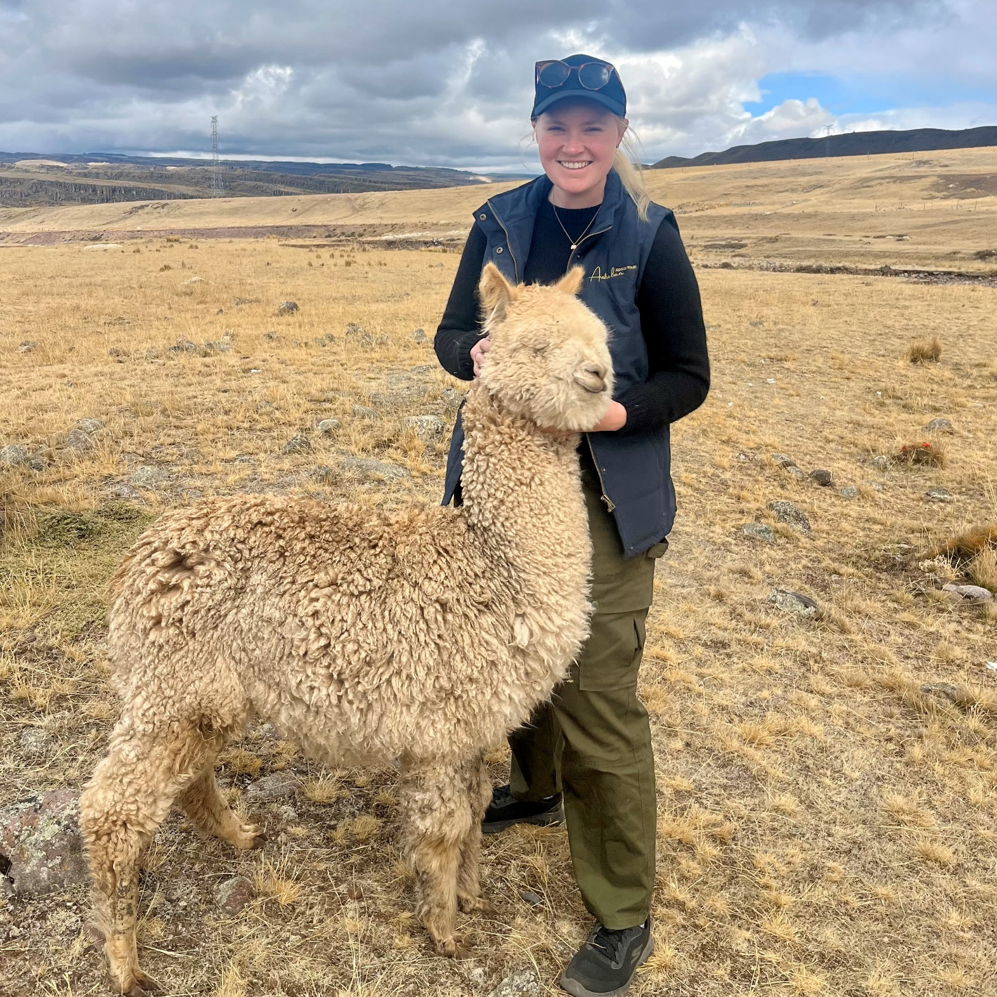

Rubey has been around alpacas her entire life.   
Based in the Central West of New South Wales Australia, her family studs are both Storybook Alpacas and Suri Alliance Alpacas and are currently running a herd of over 1,500 alpacas.   
They breed both Huacaya and Suri while focusing predominantly on white and light fawn.

Rubey’s family studs focus on the long-term viability of alpacas.   
To this end they have immersed themselves in everything the industry has to offer – from fleece, to live export, international herd management, the show movement and reproductive technologies.

In 2006, Rubey was introduced to the show ring through Junior Handling.   
Rubey has since been involved in both Young Paraders and Young Judges – as a competitor and a mentor.   
In 2019, Rubey was awarded the inaugural Agricultural Shows Australia (ASA) National Champion Young Alpaca Judge.   
Now aged only 25, Rubey has recently upgraded to be an Australian Alpaca Association Level 2 Halter and Fleece judge and was dubbed the ‘World’s Youngest accredited alpaca judge’ at the 2024 Alpaca Fiesta in Peru.

Rubey has a true love and passion for the show ring.   
Her family are active participants in the show circuit; with their animals and fleeces receiving impressive results at every show they enter.   
Impressively, her family won back-to-back Supreme Grand Champion Suri at the Australian Alpaca Association National Shows in 2023 and 2024 – with a competitive show team heading to the 2025 event.  
  
Rubey has a Bachelor of Agricultural Business Management from Charles Sturt University – a degree which has equipped her with a unique mix of business and agricultural skills.   
Rubey is a proud third generation farmer – who runs, alongside her parents, various livestock enterprises including alpacas, llamas’ meat sheep and cattle.

**Conditions of Entry**

1. All Alpacas to be penned by 8.00am Saturday 1st **November 2025**.
2. Judging to commence at 9.00am.
3. All alpacas must be registered by the Show date.
4. The exhibitor is the owner(s) listed on the IAR.
5. The age of the alpaca is the age on the day of the show.
6. All exhibitors or handlers must place their animals in the pens allotted by the convenor. Placement of animals in “trade/Sales pens” can be done with the permission of the Convenor.
7. No animal or fleece shall be removed from the show prior to the completion of judging.
8. All exhibitors must be a financial AANZ member.
9. Entry fees are non-refundable where entries are subsequently withdrawn from competition or exhibitors fail to attend the show.
10. Animals are to be entered in the correct class for the colour of the animal, not necessarily the colour shown on the IAR certificate. Colour checks can be requested at the time of registration on show day. See the Chief Steward if you have any doubts about the specific colour class of your animals.

The **Dress Code** for our show is black trousers/skirt and white shirt/blouse and preferably black shoes. Having all exhibitors dressed neatly in a similar attire makes for a professional image to the public.   
**“I cannot stress the importance of making a good impression to the public and Judge”**  
  
**“There will be an award for the best dressed Exhibitor – Chosen by the Judge”**

**Manawatu A & P Show Schedule of classes   
Suri Breed**

|  |  |  |  |  |  |  |  |  |  |  |
| --- | --- | --- | --- | --- | --- | --- | --- | --- | --- | --- |
| **SURI  BREED** | | **White** | **Light**  **Fawn** | **M/D**  **Fawn** | **Brown** | **Roan** | **Grey** | | **Fancy** | **Black** |
| Junior  6 & under 12 months | **F** | 100 | 101 | 102 | 103 | 104 | 105 | 106 | | 107 |
| **M** | 110 | 111 | 112 | 113 | 114 | 115 | 116 | | 117 |
| Intermediate  12 & under 24 months | **F** | 120 | 121 | 122 | 123 | 124 | 125 | 126 | | 127 |
| **M** | 130 | 131 | 132 | 133 | 134 | 135 | 136 | | 137 |
| Adult  24 & under 48 months | **F** | 140 | 141 | 142 | 143 | 144 | 145 | 146 | | 147 |
| **M** | 150 | 151 | 152 | 153 | 154 | 155 | 156 | | 157 |
| Senior  48 months & over | **F** | 160 | 161 | 162 | 163 | 164 | 165 | 166 | | 167 |
| **M** | 170 | 171 | 172 | 173 | 174 | 175 | 176 | | 177 |

**Champion & Reserve Champion Female & Male Suri in all age groups.**

**Supreme Champion Suri**

**Colour Championships for Suri**

White  
Light Fawn  
Medium / Dark Fawn  
Brown  
Roan   
Grey  
Fancy  
Black

**Manawatu A & P Show Schedule of classes   
Huacaya Breed**

|  |  |  |  |  |  |  |  |  |  |
| --- | --- | --- | --- | --- | --- | --- | --- | --- | --- |
| **HUACAYA BREED** | | **White** | **Light**  **Fawn** | **M/D**  **Fawn** | **Brown** | **Roan** | **Grey** | **Fancy** | **Black** |
| Junior  6 & under 12 months | **F** | 200 | 201 | 202 | 203 | 204 | 205 | 206 | 207 |
| **M** | 210 | 211 | 212 | 213 | 214 | 215 | 216 | 217 |
| Intermediate  12 & under 24 months | **F** | 220 | 221 | 222 | 223 | 224 | 225 | 226 | 227 |
| **M** | 230 | 231 | 232 | 233 | 234 | 235 | 236 | 237 |
| Adult  24 & under 48 months | **F** | 240 | 241 | 242 | 243 | 244 | 245 | 246 | 247 |
| **M** | 250 | 251 | 252 | 253 | 254 | 255 | 256 | 257 |
| Senior  48 months & over | **F** | 260 | 261 | 262 | 263 | 264 | 265 | 266 | 267 |
| **M** | 270 | 271 | 272 | 273 | 274 | 275 | 276 | 277 |

**Champion & Reserve Champion Female & Male Huacaya in all age groups.**

**Supreme Champion Huacaya**

**Colour Championships for Huacaya**

White  
Light Fawn  
Medium / Dark Fawn  
Brown  
Roan   
Grey  
Fancy  
Black

**Special Classes:**

1. Best Dressed Alpaca – Fancy Dress up your Alpaca in a costume or theme.
2. Best Dressed Exhibitor – Will be picked by the Judges at the completion of the show.
3. Best Potential Cria – Can be of any age under 6 months of age.  
    – Can be in the show ring with its mother.  
    – Must be Halter Trained.  
    – Judges Choice of what Cria they would like to own.