BREED JUDGING: 17-18th October 2026  ENTRIES CLOSE: 24th September 2026  ENTRY FEE: $50 + gst  BREED ENTRY FORM |  | 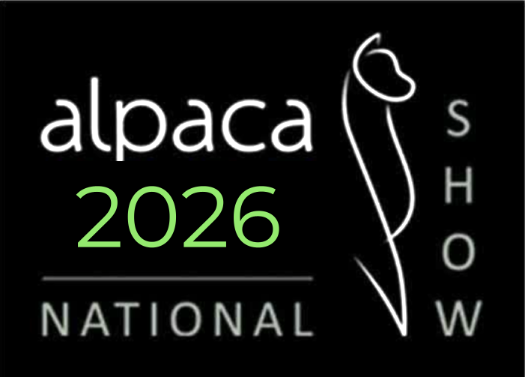 |  |  |  |  | Send To: | entries@alpaca.org.nz
Exhibitor:
Postal  Address: |  |  |  | Stud:
Postal  Address: |  |  |  | Phone No.:
Postal  Address: |  |  |  | email:

Class Number | Alpaca Name | IAR No. | Breed  (H/S) | Sex  (M/F) | Colour | Age of Alpaca at Show  (months) | Date Last Shorn  (dd/mm/yy) | Age of Fleece (months) | Entry Fee | Exhibit No. (Office)
TOTAL PAYABLE:
To be invoiced by AANZ
EXHIBITOR DECLARATION
By submitting this entry, I declare that:
- Show Regulations - I have read and understood the AANZ Show Regulations and the conditions of entry for this show. I agree to be bound by the AANZ Show Regulations, the relevant A&P Association Regulations (where applicable), and all decisions of the Show Committee and Judge(s) in relation to the conduct of the show and the competition.
- Animal Health and Biosecurity - I declare that all alpacas entered are fit for exhibition, are free from any known infectious or contagious disease and external parasites, comply with all applicable animal health, biosecurity and movement requirements, and are not subject to any movement restrictions or official notices that would prevent them from attending or being exhibited at this show.
- Registration - I certify that all alpacas entered in the show are currently registered with the International Alpaca Registry (New Zealand) [IAR(NZ)].
- Health and Safety and Liability - I acknowledge that I have read, and agree to comply with, the Health and Safety provisions contained in the AANZ Show Regulations. I accept responsibility for the safe handling, control and welfare of the alpacas I enter, will comply with all reasonable directions given by the Show Committee or Show Society, and acknowledge that my entry is subject to the indemnity and liability provisions contained in the AANZ Show Regulations.
- Accuracy of Information - I certify that all information provided in this entry is true, complete and correct to the best of my knowledge.

SIGNED: |  | DATE:

